Accenture Consulting Week journal

Last month, Hult London campus held the second Accenture Consulting Week of the year. This event is hosted by Hult 2013 graduate Marc Seipp, who is Manager of Customer Insight & Growth at Accenture. Marc has returned to Hult every year since graduation to give MBA and masters students a taste of management consulting in the real world.

We spoke to Marc – along with participating student Lucia Cazares – for a snapshot of the day.

What’s the purpose of this event?

Lucia: The whole week was an experience that successfully simulated what real-life consulting looks like in terms of understanding a new industry that you have no previous knowledge of and working within a new team to produce the best possible results for the client.

Marc: I want to give something back to the school and the students and the best way I can do that is through my experience. Through this event, Hult students get a real understanding of what the life of a management consultant is like. They experience a typical consulting project and come to learn the best methods and skillsets needed to consult successfully.

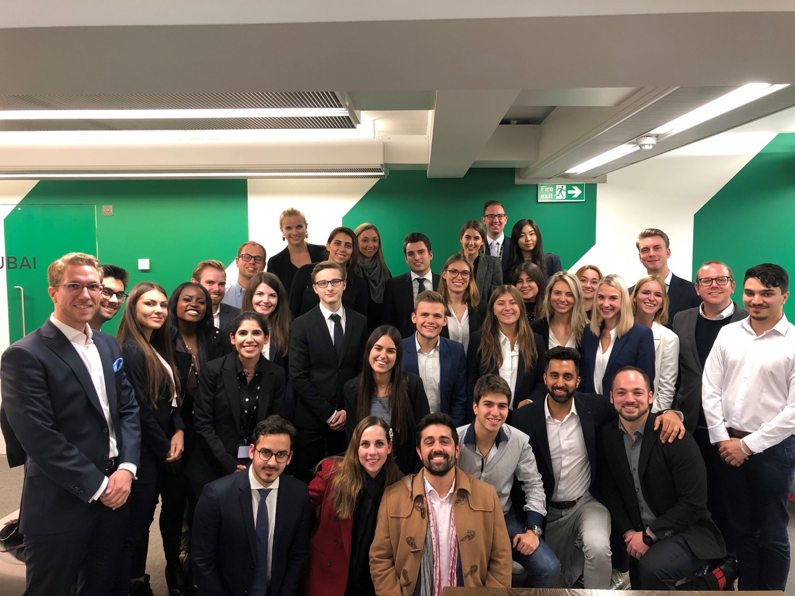
[Caption: Marc and Lucia with fellow Hult masters and MBA students during their Accenture Consulting Week challenge.]

What was your highlight from the challenge?

Lucia: The pitch presentation was a lot of fun! We were challenged in every aspect of our presentation. And we were challenged in ways we did not expect to be. The constructive feedback we received was very useful and will serve us well in future presentations.

Marc: Every time I run this event, it stands out in its own way. I found the dynamics of each group absolutely fascinating. Hult has a very engaging study body. Hult students have a genuine hunger to learn and experience what consulting really means and that in itself is rewarding.

Marc, which teams stood out to you?

Marc: All the teams were really proactive. You could feel the energy in the room and each team’s desire to win. It was great to see the strong competition between the teams.

How do events like these strengthen the Hult network?

Lucia: This was my first alumni-led experience since I joined Hult in September. It was so well organized. A lot of thought was put into it to make it as challenging and fun as possible.

Marc: In our Germany office, we have quite a few Hult alumni now working in different areas within consulting. And it’s great to see that the overall number is increasing worldwide over time. Exciting times ahead for sure. We’re already looking forward to the next Accenture Consulting Week at Hult!

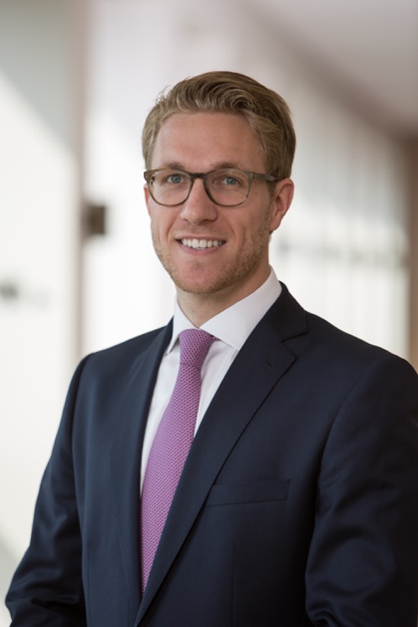
[caption: Marc Seipp, Hult Masters in International Business graduate from the Class of 2013 and Accenture Customer Insights & Growth Manager.]

